March 6, 2017

Ms. Christy Stinson Assistant Director of Finance
Carroll Independent School District 2400 N. Carroll Ave.
Southlake, Texas 76092-3105 Dear Ms. Stinson:
I am pleased to inform you that Carroll Independent School District has earned a Transparency Stars Award in the area of Debt Obligations. Our website now displays your award status and the link you submitted in your application. Enclosed is your Transparency Stars Award Certificate.
You will also receive a digital Transparency Stars seal you may post on your website.

Note that you are required to maintain and update your transparency content to retain your Star. Comptroller staff will perform regular checks of your site.

Congratulations on your success in demonstrating exemplary efforts toward financial transparency.

Sincerely,
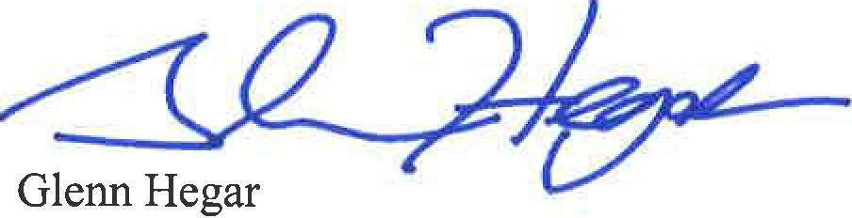

Enclosure

Comptroller.Texas.Gov
P.O. Box 13528
Austin, Texas 78711-3528
512-463-4444
Toll Free: 1-800-531-5441 ext: 3-4444
Fax: 512-463-4902

