CARROLL ISD PURCHASING PROCEDURES

Goal: To ensure a systematic process to review and approve the purchase of goods and services in compliance with federal grants requirements, state law, Board Policy and local procedures.
Purchase Order Approval Authority:
- The Superintendent has delegated the Assistant Superintendent for Financial Services to approve all purchases that are less than $50,000.
- The Assistant Superintendent for Financial Services is responsible for approving any purchases between $5,000 and $50,000.
The Board of Trustees retains the authority to approve all contracts for the purchase of goods or services for any single purchase that exceeds $50,000.

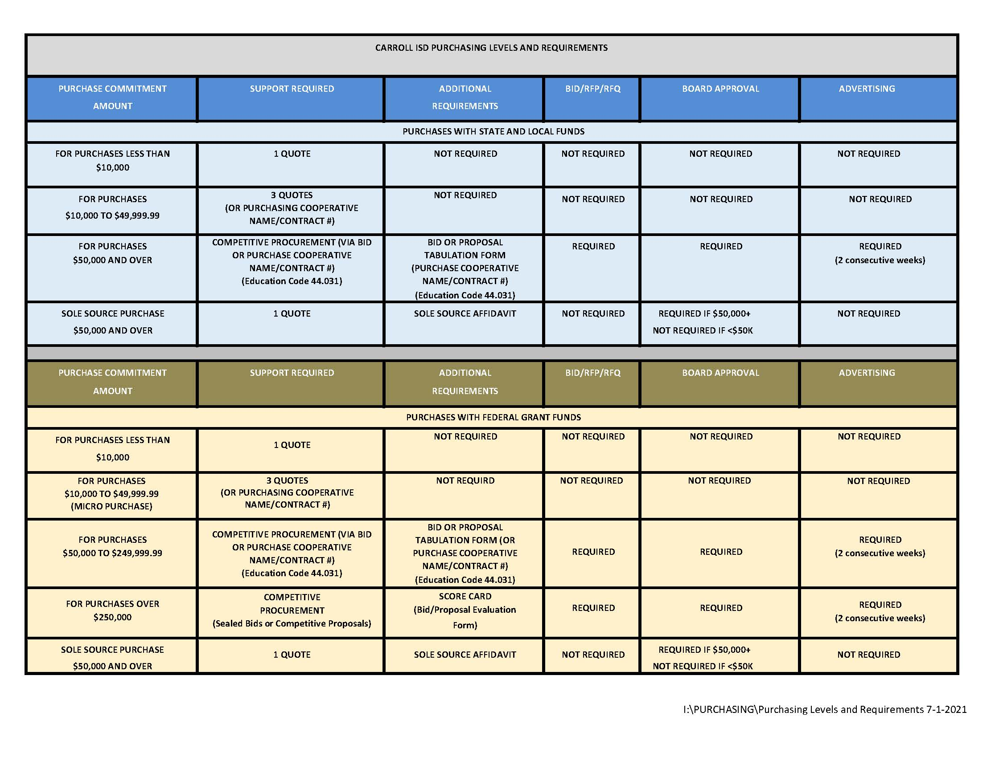
On-Line Requisition System:
- The district shall use an on-line requisition system for all purchases.
- The Executive Director of Finance shall create all requisition system users and assign the appropriate account code(s).
- The Executive Director of Finance shall create all of the requisition approval paths in accordance with the district’s Purchasing Flow Chart.

Purchase Requisitions:
- Requisitions are internal documents and should not be forwarded to a vendor to place an order.
- All requisitions from grant funds (state/federal) shall comply with the TEA Guidelines for Related Costs and the State & Federal Grants Handbook, including EDGAR requirements.
- The requestor shall submit a purchase requisition (request) using the on-line requisition system.
  - If the vendor the requestor intends to purchase from does not exist in the vendor database, the requestor shall follow the Adding and/or Renewing Vendors Procedures.
  - If the account code(s) the requestor intends to purchase with do not have sufficient funds, the requestors shall follow the Budget Change/Amendment Procedures.
- The requestor shall attachment documents for requisitions such as order forms, registration forms, or other special instructions to the requisition when they are created. Any special instructions should be added to the Notes tab. The attachment(s) shall include the system-generated requisition number.
  - If the requisition is for travel, follow the Travel Procedures.
  - If the requisition is for a field trip, Co-Curricular, or Extra-Curricular trip, follow the Student Travel Procedures.
  - If the requisition is for the purchase of food and non-food items, follow the Food and Non-Food Purchase Procedures.
- The campus principal or department head shall review and approve all requisitions.
- The Director of Purchasing shall review all requisitions prior to releasing the requisition for review by the Executive Director of Finance or Assistant Superintendent for Financial Services.
  - The Director of Purchasing shall review the pending requisitions, at a minimum, once per day.
- The review shall include the following:
  - Requestor name
  - Shipping address
  - Vendor name
  - Reason - Verify that the reason matches the purchase and is properly spelled out
  - Reference – Name of person (and room number if classroom teacher) that goods should be delivered to
  - Attachment - such as quotes, invoices, registrations, receipts, etc.
  - Bid Number – Bid, quote, or Co-Op contract number, as appropriate. NOTE. If the requisition is for goods or services that were competitively procured, a copy of all bid/proposals shall be on file in the purchasing department.
  - Catalog number for all items.
  - Description – Detailed description of item or service (exceptions may include: Web Order, Order List attached, Contract/Scope of Services attached, etc.
  - Unit of measure
  - Unit price – If equipment with a unit cost equal to or over $5,000, the object code must be 66XX
  - Account code(s) – the account code(s) must match the purchase and location/department
- If any deficiencies are noted with a requisition, the Purchasing Specialist shall contact the requestor to resolve the discrepancies.
  - If the discrepancies cannot be remedied, the Purchasing Specialist shall deny the requisition will be returned to the requestor.
- The Director of Purchasing shall “approve” all requisitions that meet the required review.
- The Director of Purchasing shall notify the Executive Director of Finance and Assistant Superintendent for Financial Services if any requisitions are pending final approval or are time sensitive.

Purchase Orders:
- Purchase Orders are similar to a “promissory note” in the sense that it conveys to the vendor that if they provide the goods or services, the district promises to promptly pay for the goods or services.
- The Assistant Superintendent for Financial Services or Executive Director of Finance shall serve as the final approver of all requisitions. Upon approval, the requisition becomes a purchase order and is assigned a system-generated number.
- The Director of Purchasing shall print copies of all purchase orders.
  - The Director of Purchasing shall print purchase orders, at a minimum, once per day.
- The Director of Purchasing shall distribute the purchase orders as noted below:
  - District copy – 1 for Accounts Payable Specialists and the appropriate vendor

- The District copy shall be filed for all purchase orders in an alphabetic file pending receipt of the invoice, packing list, and receiving confirmation, all documents will be attached to the voucher payment records.

Petty Cash:
- Each campus, the Child Nutrition Department, the Transportation Department and the Financial Services Department are authorized to have a petty cash account. The petty cash accounts shall be in the following amounts:

FUND | ORGANIZATION | BALANCE | TIME PERIOD
Child Nutrition | District Wide | $ 3,100.00 | 8/15/YY - 6/15/YY
Child Nutrition | Stadium Concessions (fluctuates as needed) | $X, XXX.XX | 8/15/YY - 6/15/YY
Athletics | Dragon Stadium | $ 2,000.00 | Year Round
Aquatics | Aquatic Center | $ 100.00 | Year Round
General Fund | Financial Services | $ 1,500.00 | Year Round
General Fund | Transportation | $ 250.00 | Year Round
General Fund | Marketing | $ 200.00 | Year Round
Activity Accounts | Carroll High School | $ 200.00 | Year Round
Activity Accounts | Carroll Middle School | $ 400.00 | Year Round
Activity Accounts | Dawson Middle School | $ 400.00 | Year Round
Activity Accounts | Carroll Elementary School | $ 200.00 | Year Round
Activity Accounts | Johnson Elementary School | $ 200.00 | Year Round
Activity Accounts | Rockenbaugh Elementary School | $ 200.00 | Year Round
Activity Accounts | Old Union Elementary School | $ 200.00 | Year Round
Activity Accounts | Eubanks Intermediate School | $ 200.00 | Year Round

- Each transaction shall be supported with an original, detailed receipt and a Petty Cash Voucher.
- To replenish petty cash accounts, the campus or department secretary/bookkeeper shall prepare a Petty Cash Reimbursement Form
- The campus or department secretary/bookkeeper shall ensure that the reimbursement form is supported by original, detailed receipts and shall verify the charges, add the account code(s), and forward to the campus principal or department head for review and approval.
  - Sales tax shall not be reimbursed with petty cash funds.
- The campus principal or department head shall review and approve all Purchase Transaction Logs.
- The District Accountant shall review all Petty Cash Reimbursement Forms prior to releasing the requisition to Accounts Payable in accordance with Accounts Payable Procedures.
- The review shall include the following:
  - Original, detailed receipt – the reimbursed amount must not include sales tax
  - Account code(s) for each transaction – the account code(s) must be appropriate for the purchase
  - Approval from the campus principal or department head
- If any deficiencies are noted with a Petty Cash Reimbursement Form, the Assistant Executive Director of Finance shall contact the requestor to resolve the discrepancies.
  - If the discrepancies cannot be remedied, the District of Accountant shall return the Petty Cash Reimbursement Form to the requestor.

District Purchased Employee/Coaching Attire:
All purchases for employee attire must be charged to a 461 Activity Account.

CARROLL ISD CREDIT CARD PROGRAM

PURCHASING CARDS Purchasing Cards are issued to Carroll ISD employees with the
TRAVEL CARDS role and responsibility for acquisition of goods and services necessary for the effective and efficient operation of school academic, and administrative departments.

CURRENT CARDS ISSUED Current Purchasing Card holders include
Campuses
Carroll Senior High School (2 cards)
Carroll High School (2 cards)
Carroll Middle School (1 card)
Dawson Middle School (1 card)
Durham Intermediate School (1 card)
Eubanks Intermediate School (1 card)
Carroll Elementary School (1 card)
Johnson Elementary School (1 card)
Old Union Elementary School (1 card)
Rockenbaugh Elementary School (1 card)
Walnut Grove Elementary School (1 card)

Departments
Athletics (1 card)
Communications Services (1 card)
Child Nutrition Services (1 card)
Financial Services (2 cards)
Maintenance Services (1 card)
Personnel (1 card)
Staff & Student Services (1 card)
Superintendent’s Office (1 card)
Transitions Services (1 card)
Transportation Services (1 card)

Administrators (Issued in Administrator’s Name)
Assistant Superintendent for Financial Services (1 card)
Assistant Superintendent for Operations (1 card)
Assistant Superintendent for Staff & Student Services (1 card)
Executive Director for Athletics (1 card)
Deputy Superintendent (1 card)
Executive Director for Communications (1 card)
Superintendent (1 card)

Cards issued in an individual’s name have the administrator’s
name and Carroll ISD embossed on the front of the card. Each
card holder is subject to all State laws and District Policies with regards to purchases. The card will have no impact on the holder’s personal credit.

CURRENT TRAVEL CARDS Current Travel Cardholders
Campuses
Carroll Senor High School (1 card)
Carroll High School (1 card)
Carroll Middle School (1 card)
Dawson Middle School (1 card)
Durham Intermediate School (1 card)
Eubanks Intermediate School (1 card)
Carroll Elementary School (1 card)
Johnson Elementary School (1 card)
Old Union Elementary School (1 card)
Rockenbaugh Elementary School (1 card)
Walnut Grove Elementary School (1 card)

Departments
Athletics (1 card)
Curriculum & Instruction (1 card)
Personnel (1 card)
Special Programs (1 card)
Technology (1 card)
Transportation (1 card)

These cards are used mainly for travel reservations to hold a hotel or other travel related item.

Travel Check Out Cards
We have a set of 50 rotating travel credit cards, held by the Secretary to the Assistant Superintendent for Financial Services. These cards have a limit of $1 until they are pulled to be issued to a traveler. At that time the card limit will be increased to cover the estimated travel.

Cards will be issued only when the following steps are completed
- A completed travel form is received by the Financial Services Department
- The form must be completed signed by the required individuals (ex. Principal, Department Head, Appropriate Assistant Superintendent and Superintendent as needed.
- The travel form will have every anticipated expense for the travel event listed and an amount estimated. (i.e. hotel, per diem, mileage or vehicle rental, registrations, fuel, parking, tolls, employee meals, student meals, etc.)
- Some of the anticipated expense may be covered by a normal Purchase Order. Some, such as hotels, tolls, etc. may need to use the Commerce Bank card.

The Secretary to the Assistant Superintendent for Financial Services will verify all anticipated expenses, review for accuracy, completeness, and that appropriate Purchase Orders have been entered prior to issuing the travel credit card.

The traveler must follow the district’s travel procedures. It is mandated that the card, all appropriate receipts and the completed travel form (listing actual expenses as opposed to estimated expenses) be returned to the Financial Services Department no later than 5 days after travel.

UNDER NO CIRCUMSTANCES SHOULD THESE CARDS BE USED FOR PERSONAL PURCHASES.

Campus and Department users include Campus Principals, school secretaries, Department Heads, and Department Secretaries and a limited number of other campus/department personnel. Cards are checked out and logged by the campus/department card holder. No card should be checked out without a valid approved Purchase Order issued to Commerce Bank with the purpose of the request listed in the body of the Purchase Order. When not in use cards should always be locked either in a file cabinet or safe.

CARD ISSUANCE PROCESS Prior to the receipt of cards, all card holders (campus, department, administrators) will be instructed on the appropriate and allowable uses for use of the card. When a card is issued the Campus / Department / Administrator will be required to complete a Card Holder Agreement. A copy of this agreement follows. Signature are required before the card will be issued.
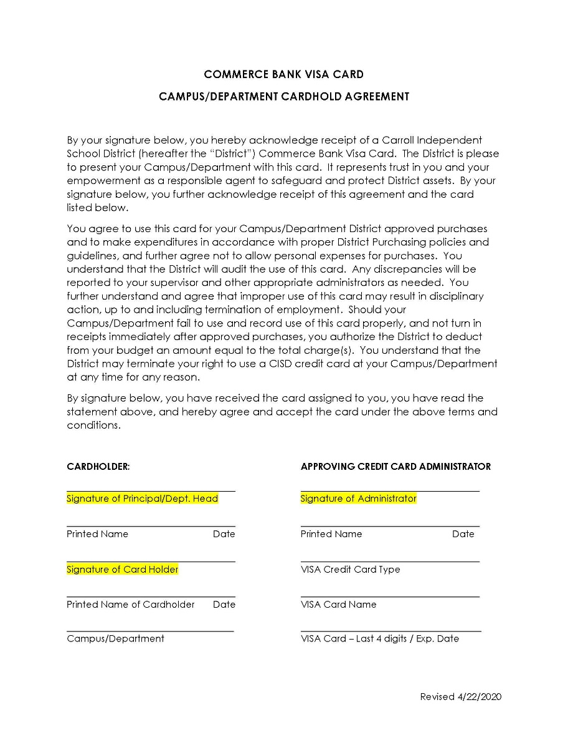
Improper use or abuse of the credit card or violation of purchasing card procedures may result in revocation of the card and will subject the employee to disciplinary action up to and including termination from the District.

ACCEPTABLE USE Prior to any use of the credit card, a Purchase Order must be entered into the Skyward Finance system, and be fully approved. The Purchase Order should be made payable to Commerce Bank, and list a purpose and estimated amount of the purchase.
Examples of appropriate uses include:
- Registrations for staff training
- Registrations for student events (athletic fees/other)
- FedEx / UPS / USPS shipping and postage charges
- Required for special discounts
- Online purchasing, where the vendor does not accept a PO
- Food for training events (normally out of 461 funds)
- Food for student events (normally out of 461 funds)
- Operational supplies
- Event scheduling
- Courier services
- Instructional supplies
- Travel Expenses related to School Business
- Other miscellaneous items that pertain to your academic or extra-curricular program
This list is not all-inclusive, for questions please contact the Financial Services Department.

CARD LIMITS Each Purchasing/Travel Card has a designated set credit limit, based on the type of user and anticipated needs. Charges to the Commerce Bank card are automatically paid and reconciled on a weekly basis. If any discrepancies are discovered during the monthly reconciliation the district has the option to:
- Dispute the charges with Commerce Bank; requesting a refund, or
- Dispute the charges with the employee, if the charges do not match the charges listed on the approved PO. Thus allowing the district to require repayment by the employee.

If circumstances require a specific card limit to be increased, the card holder must email the Director of Purchasing with the requested increase amount and why the request is being presented, as well as the last four digits of the card. The Campus/Department head should be carbon copied on the request. The Director of Purchasing will review and have the Executive Director for Finance approve, prior to any credit limit change. This will be a temporary (1 week) increase until the next bill drops, at which time the limit will be reduced back to the normal limit.
UNALLOWABLE USE Charges will be monitored on a monthly basis, at the time of reconciliation. The following items are examples of unallowable charges.
- Alcoholic beverages
- Tobacco
- Lottery Tickets
- Cash Advances / ATM
- Entertainment (except for student field trips or travel, must be pre-approved)
- Gift certificates, gift cards, Group-ons
- Gratuity exceeding the District’s 15% limit
- Personal purchases
- Fuel for personal vehicles
- Uber or other group ride shares
This list is not all-inclusive. If you have specific questions, please contact the Financial Services Department.
CARD DECLINED If your card is declined, and you feel the charges would be deemed allowable; contact the Financial Services Department during normal business hours for assistance. If it is an emergency after hours and cannot wait till the next business day, you may contact the On-Call phone at 817-247-7179.

SALES AND USE TAX Carroll ISD is a tax exempt entity within the state of Texas, and does not pay sales tax. The cardholder is responsible for insuring that sales tax is not charged to the credit card. If necessary, provide the CISD Texas Sales and Use Tax Exemption Certification form to the vendor. If sales tax is charged, the cardholder is responsible for having the sales tax credited back to the same card. Do not accept cash to refund the tax.
SUPPORTING The cardholder is responsible to obtain the required Supporting
DOCUMENTATION Documentation, and to submit the originals to the Financial Services Department within 24 hours of the purchase, if using a Purchasing Card or within 5 days after travel if using a Travel Card.
Acceptable Receipts
- Original receipt
- Vendor / Merchant name
- Date of transaction
- Clear description of items purchased
- Detailed costs, including any sales taxes or delivery charges

Unacceptable Receipts
- Copy / not original
- Vague descriptions (not detailed)
- Product numbers in lieu of transactions
- Lack of amount paid to vendor

LOST OR STOLEN CARDS Cardholders must immediately report a lost or stolen card to the Financial Services Department. The cardholder must submit a written request to cancel the lost or stolen card as soon as the loss is discovered. Financial Services will immediately contact Commerce Bank and deactivate the card, review any recent charges, and dispute any that were not made for CISD.

A replacement card will be requested; and the cardholder will need to complete a new Cardholder Agreement Form for the new card.

CARD SECURITY All cards must be secured
- Stored in a locked file cabinet or safe
- Do not share the card or the card number with anyone
- Do not give to a vendor to “keep on file.”

CREDIT CARD The Director of Purchasing is responsible for maintaining all records
RECONCILIATION related to the requesting and issuance of Purchasing Cards and Travel Cards.

- On a weekly basis the credit card statements are presented for automatic payment.
- Commerce Bank closes each statement on Tuesday, and drafts the funds from the CISD Independent Bank Electronic Payments Outgoing Account
- The District Accountant prints the statement, and transfers funds to cover the automatic payment.
- The District Accountant will pull the statement each week and reconcile the statement with district records.
- After each credit card statement is reconciled, the District Accountant will review and forward to Accounts Payable to issue payment within Skyward, which will update all accounts within the system.

