Texas Comptroller Leadership Circle Silver Member
awarded to

Carroll ISD
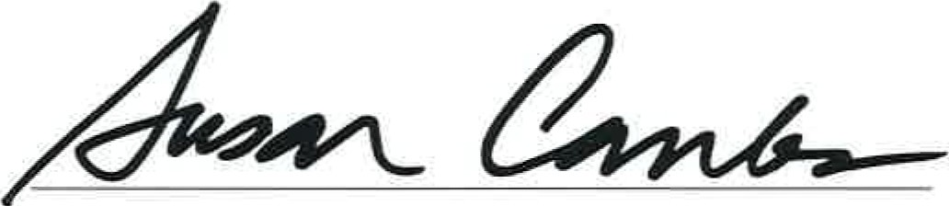
For continued progress toward achieving financial transparency. The Texas Comptroller's Leadership Circle program recognizes local governments across Texas that are striving to meet a high standard for financial transparency online. Your efforts to provide citizens with clear, consistent pictures of spending and share information in a user-friendly format have paved the way for achieving greater financial transparency.

October 30, 2014

