BUDGET
PROCEDURE MANUAL

2021-2022

Carroll Independent School District

Creating an environment that fosters excellence.

Contact Information

William Wooten
Assistant Superintendent for Financial Services
William.Wooten@southlakecarroll.edu
817-949-8272 (phone)
817-949-8277 (fax)

~~~~~~~~~~~~~~~~~~~~~~~~~~~

Laurie Grissom
Executive Director of Finance
Laurie.Grissom@southlakecarroll.edu
817-949-8271 (phone)
817-949-8277 (fax)

~~~~~~~~~~~~~~~~~~~~~~~~~~~

Sheryl Hall
Accountant
Sheryl.Hall@southlakecarroll.edu
817-949-8257 (phone)
817-949-8277 (fax)

TABLE OF CONTENTS

Section 1 Budget Memo 4

Section 2 Budget Calendar 5

Section 3 Budget Overview, Instructions for Skyward
Data Entry 6

Section 4 Account Code Structure 15

Section 5 Coding, Guidance and Tips 17

Section 6 Expenditure Object Code Alphabetic Listing 25

Section 7 Budget Maintenance throughout the Year 27

Section 8 Approved Vendors 28

Section 9 Appendix – Forms 29

SECTION 1

BUDGET MEMO

The 2021-2022 budget allocations will be based on the same criteria as 2020-2021 adjusted for student enrollment changes and one-time requests.

Although the State is no longer emphasizing expenditure targets of 65% in instruction, it is still a good practice. Because transparency is still a critical issue, extra caution should be taken to ensure proper account numbers are used when planning next year’s budget and when coding expenditures.

As you prepare the 2021-2022 budget for your campus or department, please consider the following:

- 65% Instructional – It is still a good idea to allocate approximately 65% of your campus budget to function 11. See Section 4 and Section 5.

- Per Pupil Allocation – Should include all costs (excluding salary and benefits) for basic education to every student such as classroom supplies, support staff supplies, district paid field trips, professional development and substitutes.

- Campus Improvement Plan – Budget should reflect needs outlined in CIP and discussed with committee members and staff.

- Deadlines – Data entry should be completed by Friday, April 23, 2021. Additional Funding Requests are also due at the same time. The Skyward budget component will be closed at 5:00 p.m. on April 23, 2021.

The budget will be entered directly into Skyward. Instructions for the electronic submission are included in Section 2.

You are encouraged to utilize sub-objects, program intent codes and local option codes to better identify your budget based on programs. Information regarding these numbers can be found in Section 5.

Also included in this manual are tips and coding guidance.

Any questions regarding the budget process may be addressed to Laurie Grissom, by phone at extension 8271 or by e-mail at laurie.grissom@southlakecarroll.edu.

SECTION 2 BUDGET CALENDAR
2021-2022

January 11 Board Meeting: Adopt 2021-2022 School Calendar

January 13 Budget Calendars Distributed at DLT

February 1

Board Meeting:
Present Demographer’s Enrollment Projection

March 9 Distribute Budget Allocations

March 25 Budget Workshop w/Campus & Department Secretaries

March 29 Board Meeting: Staffing Plan is Presented/Approved

April 23 Campus & Department Budget Detail Due in Skyward

April 30 Preliminary Estimated Property Value Tax Roll Received

May 3 Board Meeting: Budget Projection #1

May 30 Updated Preliminary Property Value Estimate Received

June 7 Board Meeting: Budget Projection #2

June 21 Board Meeting: Adopt 2021-2022 Compensation Plan

June 30 Updated Preliminary Property Value Estimate Received

July TBD Board Meeting: Budget Projection #3

July 25 Certified Property Values Received

August TBD Budget Workshop: Budget Projection #4

August TBD Submit Newspaper Ad for Final Notice of Public Meeting to Discuss
Budget to Fort Worth Star Telegram

August TBD Board Meeting: Public Hearing to Discuss Budget
Adopt 2021-2022 Budget
Adopt 2021-2022 Tax Rate

September 1 Beginning of 2021-2022 Fiscal Year

September 1 Submit Tax Rate to Tarrant County Tax Office & Tarrant Appraisal District

SECTION 3

BUDGET OVERVIEW AND
INSTRUCTIONS FOR DATA ENTRY IN SKYWARD

Site-based budgeting places the administrator at the center for the budget preparation process. Administrators act as budget managers for their organization and are responsible for both the preparation and maintenance of their budget. With the exception of salaries, the District allows each organization to budget their allotment to meet the specific needs of your organization or program.

Your budget should include amounts sufficient to cover the costs of travel, registration fees, instructional materials and supplies for each classroom, department, and/or program for which you control.

Budgets will be entered directly into the Skyward system via the web application. The following pages of this manual you will find instructions for entering next year’s budget. It is a step by step, screen by screen how-to for entering the budget into Skyward.

Directors, department heads, and principals have been given the appropriate access for budgeting. Finance Department personnel will be available to answer any questions and give one-on-one assistance as needed. Please contact Laurie Grissom extension 8271 or at laurie.grissom@southlakecarroll.edu.

Final budgets should be entered by April 23, 2021. At 5:00 p.m. on April 23, 2021 access to the Skyward budget component will be closed. Any balances not entered into the system will not be in next year’s budget.

CURRENT YEAR INSTRUCTIONS

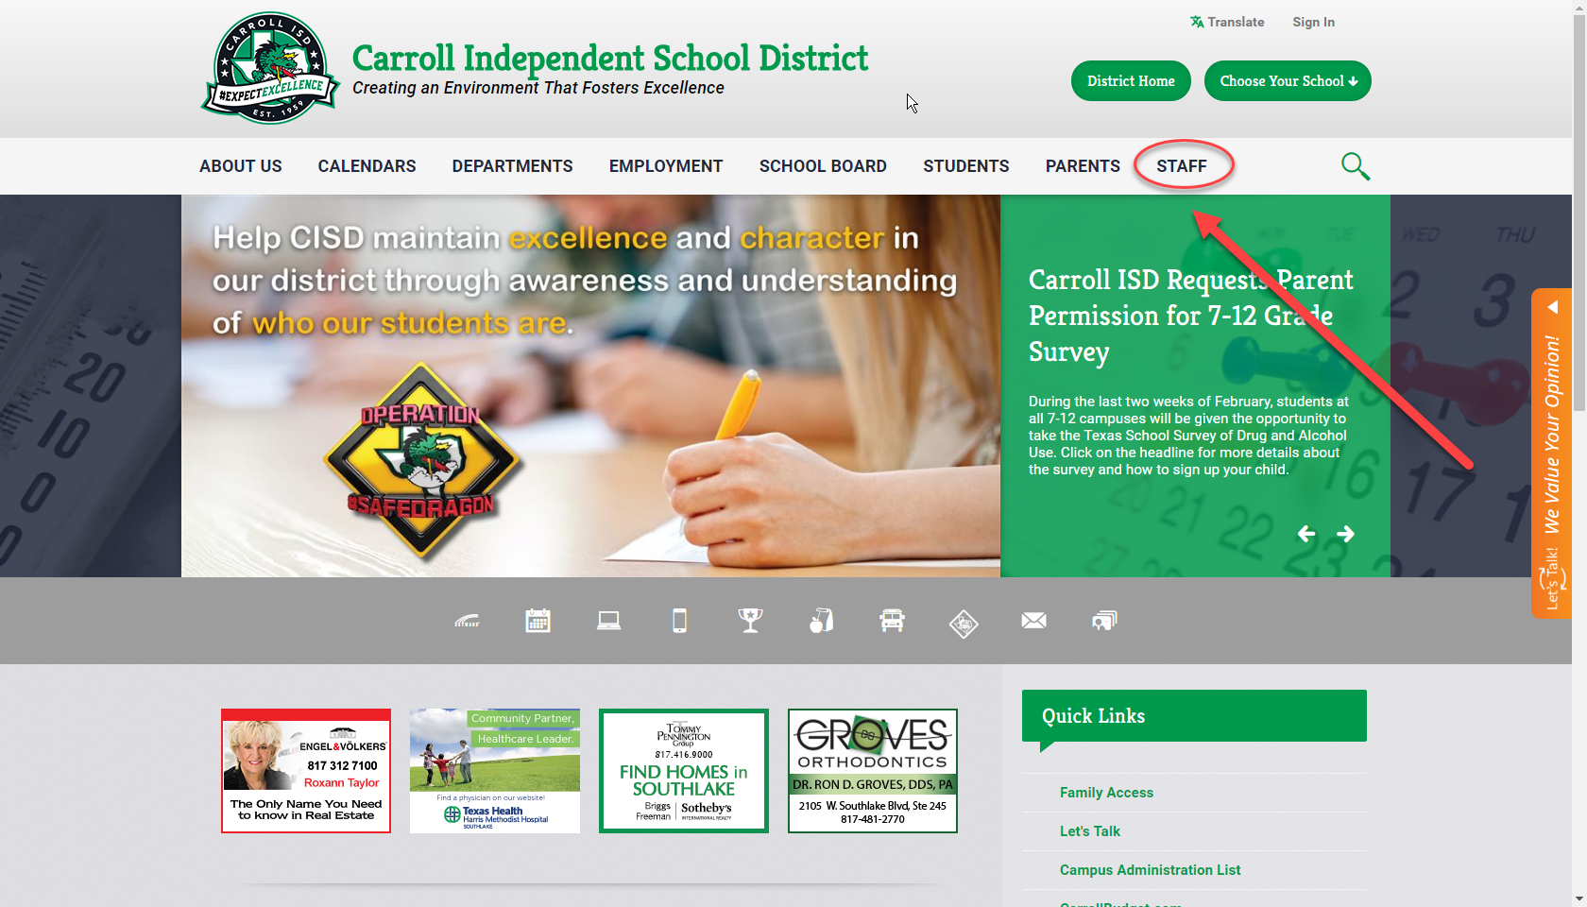

Log onto the district website (www.southlakecarroll.edu)
Click on the Staff button on the top row.

You will be taken to the following site
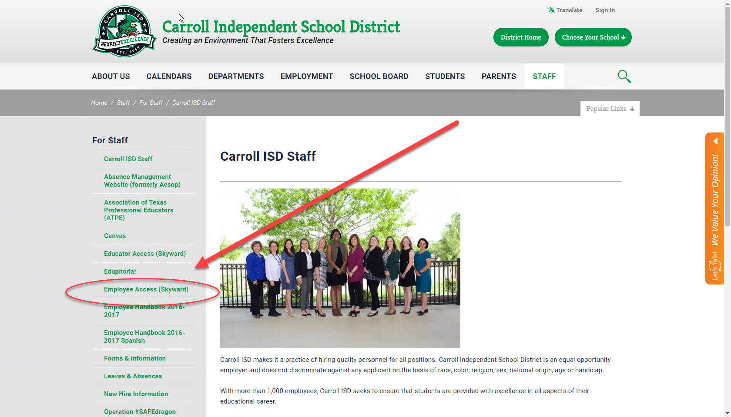

On the left hand side click on Employee Access (Skyward).
This will lead you to the Skyward Employee Access login. Enter your individual “E” number as your login ID and your password.
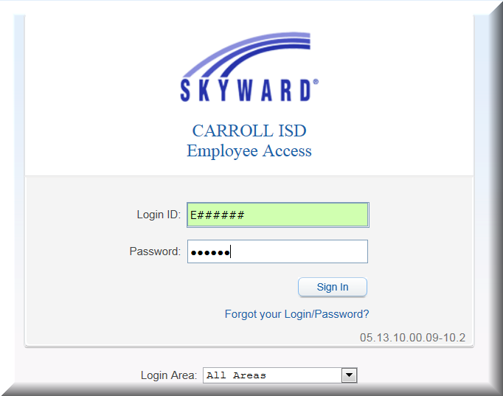

You may land on the Employee Access page.
Click on the drop down arrow on the top left; you will then be able to highlight
Financial Management, click on this button.

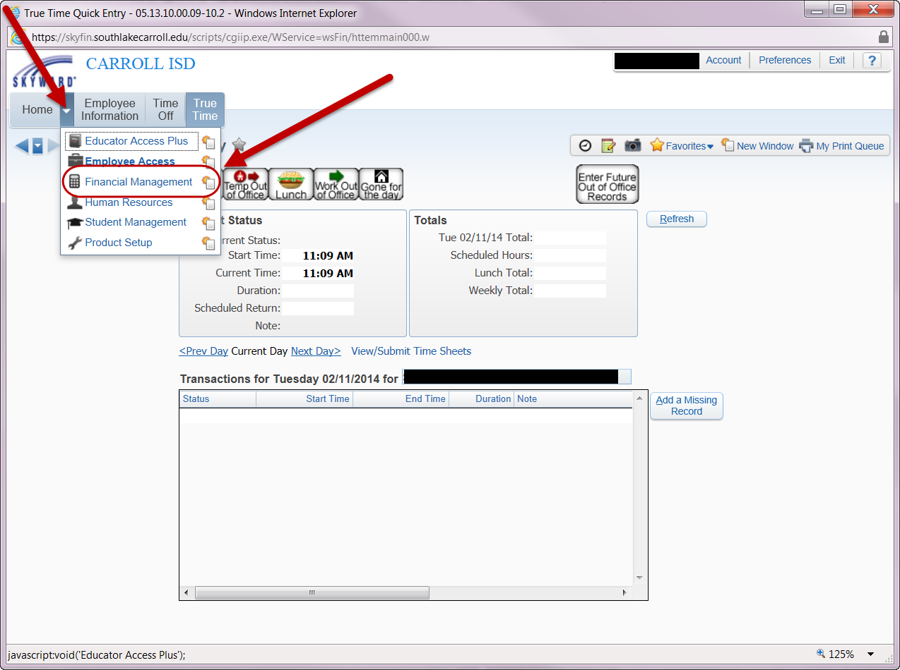
You should now be on the Financial Management page. Click on Account Management at the top of the page, then click on Budget Entry – BE, in the center of the page.

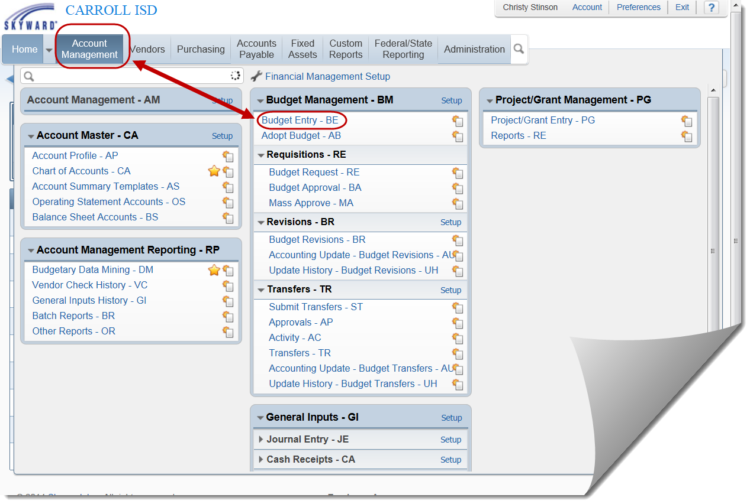

Highlight the appropriate 2021-2022 Campus/Dept. process. Click on the Individual Budget Entry button on the right side of the screen.

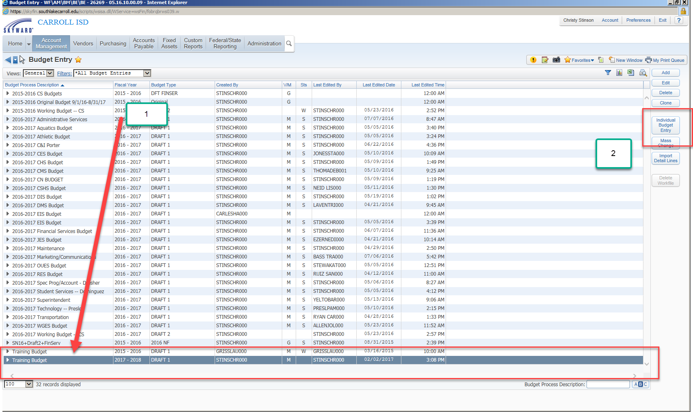
The screen that comes next should appear as below; but with your specific campus/department information:

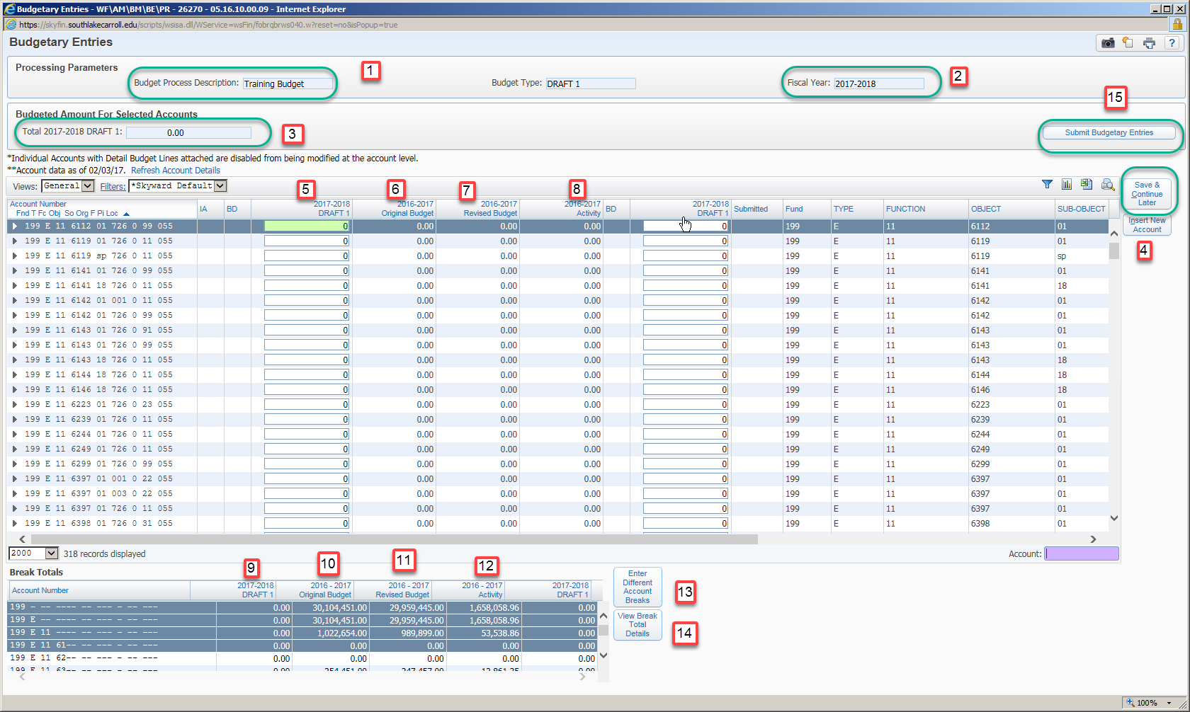

You should now see your campus/department budget information. You may view your current 2020-2021 budget numbers and your actual activity for each account line. Using the allocation amount issued to you begin entering your budget data.

- Item 1: Title of Budget Template – Make sure it is yours.
- Item 2: Fiscal Year – Make sure it is 2021-2022.
- Item 3: A running total of what you have entered into your budget – gives you a way to make sure all funds are budgeted up to the allocation amount.
- Item 4: If you are interrupted or cannot finish in one setting use the “Save & Continue Later” button.
- Item 5: Column 1 is where you enter your 2021-2022 allocation figures. The detail amounts from your 2020-2021 budget have been populated for you. To make changes to this detail, click on the arrow next to the account number to open “Detail Budget Items”. Click Add/Edit Detail Budget Items to bring up the detail. You can then Add, Edit, or Delete the line items that make up this budget amount.
- Item 6: Column 2 is your 2020-2021 Activity for each account number, as of date created. Click Refresh Account Details to get updated balances.
- Item 7: Column 3 is your 2020-2021 Revised Budget, as of date created.
- Item 8: Column 4 is your 2020-2021 Original Budget, as of date created.
- Item 9: Summary of 2021-2022 figures based on your breaks, should equal your total budget when finished.
- Item 10: Summary of Column 2
- Item 11: Summary of Column 3
- Item 12: Summary of Column 4
- Item 13: Allows you the ability to change how the breaks are summarized. (i.e. you can break by fund, function and object, etc.) More information is listed below.
- Item 14: View Break Total Details
- Item 15: Submit Budget Entries – only press this button if you are done and will not be entering any more information. More information follows.

*** Again, if you are interrupted or need to close out and work at another time click
on the “Save & Continue Later” button.

Detail budget entry required.

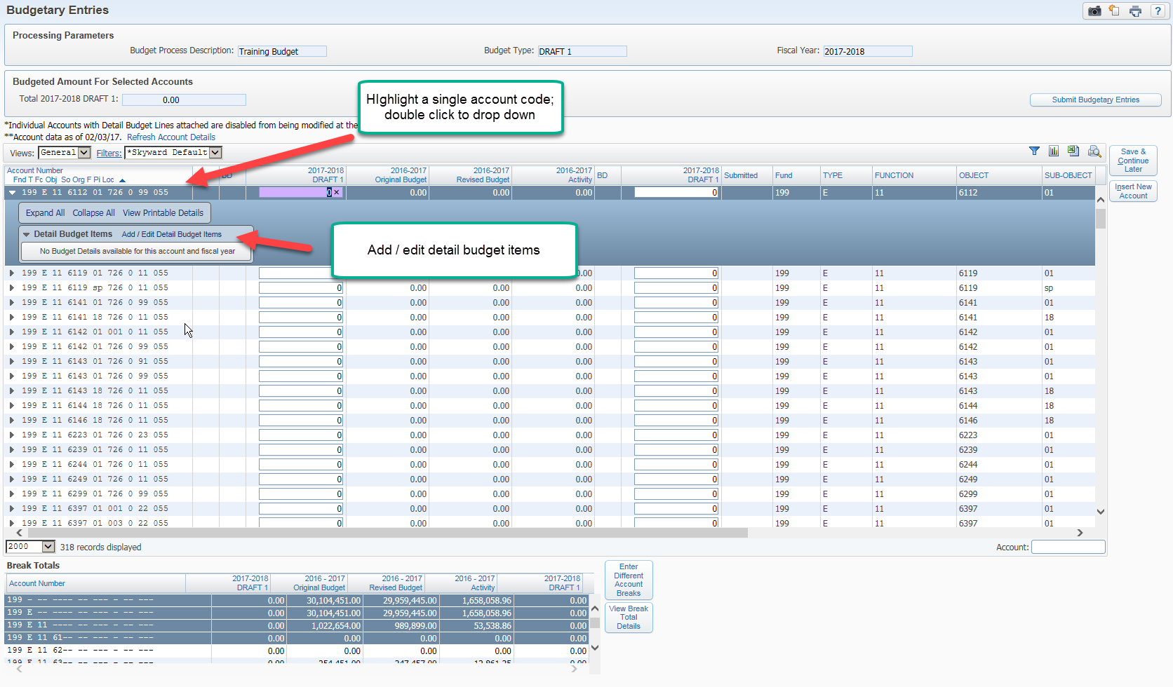
To enter detail information, highlight the account code you wish to enter information for; then “expand all.” Below you will see a box called “Detail Budget Items.”

- Click on “Add/Edit Detail Budget Items.”
- In the next box, click on Add
- Add your description along with the amount of this particular item.
- Continue doing this until you use up the entire amount you wish to place in this account.

i.e. You have $5,000 you wish to spend on 3 different training sessions. You add a detail description line and amount for each individual training.
-- $1,500 for Heart Math for S. Smith
-- $1,500 for Reading is fun training for D. Johnson
-- $2,000 for Science training for 4 teachers
-- The three detail descriptions total $5,000 for the account

Entering Different Account Breaks

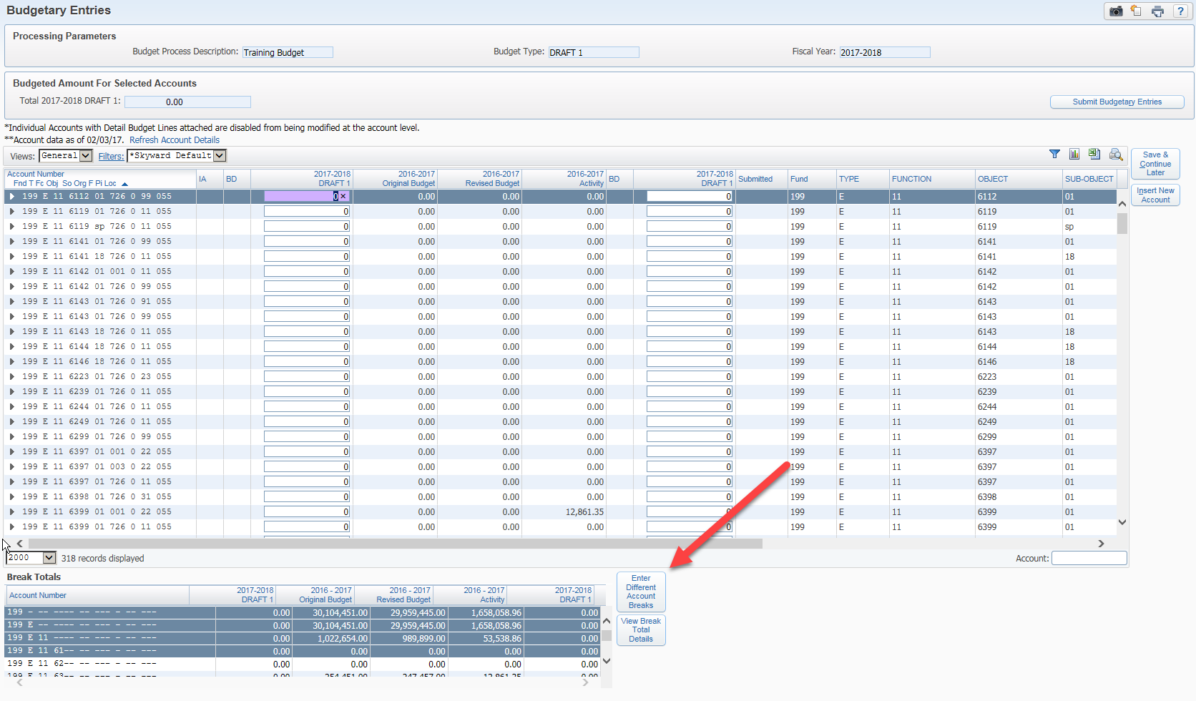

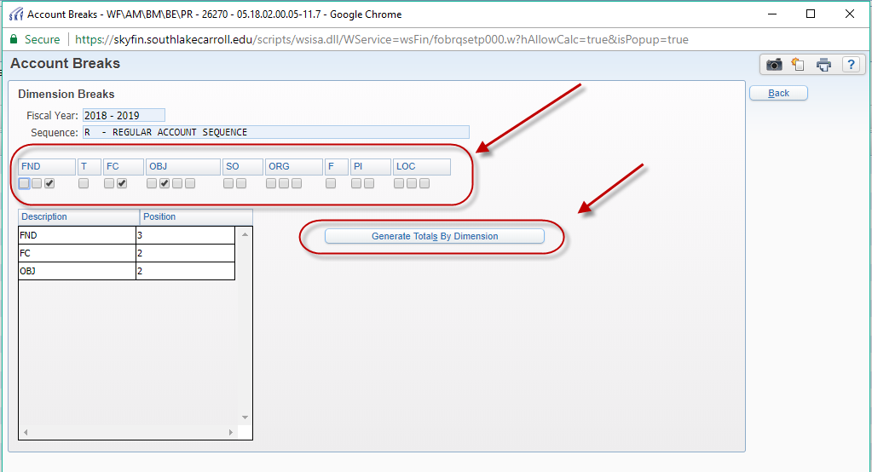

This allows you to set the breaks where you want and to view your data in different formats. This can be changed and adjusted at any time and will not affect your data entry. The example above shows breaks at the fund, function and object level. Once you make changes, click on the Generate Totals by Dimension to have the changes take effect. You may also click on the View Break Total Details button to view a summary of your totals.

If you need to leave the process at any time, be sure to click on the Save & Continue
Later button before you exit. Otherwise you may lose your work. Be sure stay within
your allocation amount. If you have any questions on this process, please contact
Laurie Grissom at extension 8271.

EXCEL EVALUATION OPTIONS

To review and print your numbers at any time during the process, click on the Excel button at the top next to the Save & Continue Later button. This will lead you through a series of steps and eventually gives you an Excel spreadsheet with your numbers. You can review numbers and/or save for future reference.

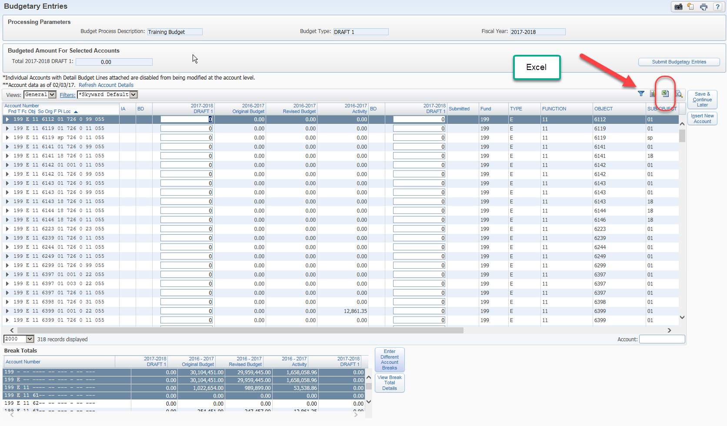

FINALIZING THE BUDGET ENTRY PROCESS

Once you have entered your budget and are satisfied with the data; you will need to finalize the process for submission:

- Press the Submit Budgetary Entries button, at the top right of the page. This writes the numbers you entered to the draft budget. The system then asks, Are you sure you want to run the update? If you are sure, then click Ok.
- You will have the option to print a report if you wish to do so. If you get an error message instead of the option to print your report contact Laurie Grissom. The system will not label your budget as “Submitted” and the numbers may not be included in the total budget.
- Click on the Update Complete – Press Close button.
- Please send an e-mail to Laurie Grissom, letting her know that you have completed your portion of the process. laurie.grissom@southlakecarroll.edu.

SECTION 4

ACCOUNT CODE STRUCTURE DEFINED

The Texas Education Code requires adoption of a standard fiscal accounting system. Financial data, adopted budget and final expenditures are reported to the Texas Education Agency (TEA) annually. This standard coding structure facilities decision making by various user groups. Below is an overview of the different sections of the code structure.

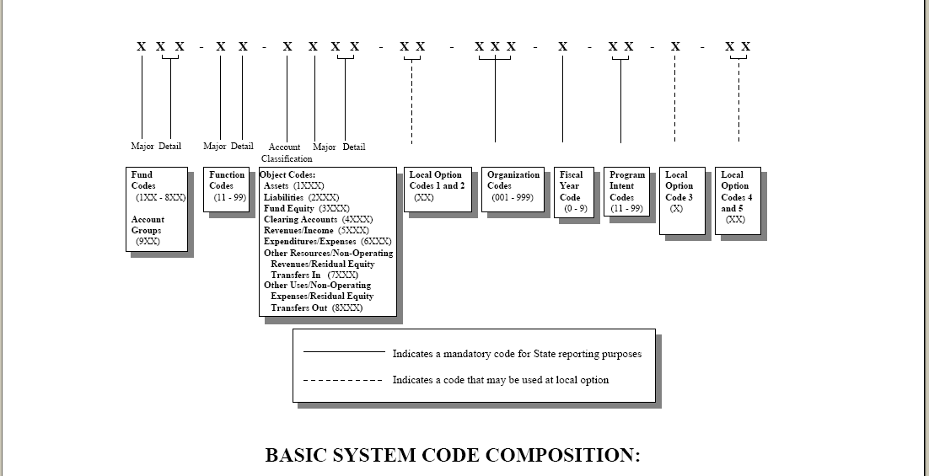

SEGMENT | # OF DIGITS | WHAT IT MEANS | EXAMPLES | PAGE #
FUND | XXX | Tells us the source of the revenue which pays for the expenditures | 199 – General Use – Local & State  2XX – Special Programs – Federal  4XX – Money specific to campuses  865 – Money specific to student groups | 19
TYPE | S | Used by Skyward automatically assigned | R – Revenue  E – Expense | 19
FUNCTION | XX | Tells the purpose of the expenditure | 11 – Any expense for direct instruction  23 – Expenses associated with campus leadership  51 – Expenses associated with Operations | 19
OBJECT | XXXX | Tells us the type of expenditure | 6100 – Payroll  6200 – Contracted Services  6300 – Supplies | 20
SUB-OBJECT | XX | CISD assigned to designate additional levels of budgeting | 00 – Undesignated  02 – Cell phones | 22
ORGANIZATION | XXX | Tells where or who | 001 – Carroll Sr. High  041 – Carroll MS.  101 – Johnson ES | 23
YEAR | 0 | Tells when | 1 digit year code | 23
PROGRAM INTENT | XX | Tells us the student group served | 11 – Basic Ed  23 – Special Ed  22 – Career & Tech | 24
DIST | XXX | CISD defined | 011 – Carroll Sr. High  021 – Adm Services | 23

SECTION 5

CODING, GUIDANCE, AND TIPS

The following may provide some clarification to frequently asked questions regarding the budget codes:
PLEASE NOTE:

Please take care to use the object codes which were changed or added for consulting services, professional services, substitutes for support staff, and fees and dues.

Personnel/Salaries
The Departments of Administrative Services and Financial Services will budget staff positions based on needs and available funding.

Substitutes
6112 -- Use this object to code substitutes for teachers and other professionals
6122 -- Use this object to code substitutes for support personnel

Extra Duty
6117 -- Use this object to code extra duty for teachers and other professionals
6121 -- Use this object to code extra duty for support personnel and overtime.

Professional Services
6219 -- This code is used to classify expenditures/expenses for professional
services rendered by personnel who are not on the payroll of the school
district. Government Code 2254.002 defines professional services to be
the following:

Architecture Accounting Medicine Optometry Landscape Architecture Land Surveying
Professional Engineering Professional Nursing Real Estate Appraising

These are professionals who are required to be licensed or registered with the state. Professional services are delivered by an independent contractor (individual, entity or firm) that offers its services to the public. Such services are paid on a fee basis for specialized services that are usually considered to be temporary or short-term in nature, normally in areas that supplement the expertise of the school district.

Professional Services
6239 -- Regional Educational Service Center expenses. (i.e. Region XI services)
This code is used to classify all contracted services provided by the Education Service Center. Included in this account are: data processing services, accounting services, media services, special education services, career and technical education services, staff development, curriculum development, drug testing and grant writing services. This does not include supplies (which should be charged to the appropriate supply account).

6269 -- This code is used to classify expenditures/expenses for other rentals-
operating leases. This includes, but is not limited to, rental or lease of: furniture, computers, telecommunications equipment, audio-visual equipment, and vehicles (not used for student travel).

Miscellaneous Contracted Services
6299 -- This code is used to classify expenditures/expenses for miscellaneous
contracted services not specified elsewhere. Examples:

Piano Accompanist Game Officials Cheerleader Judges
Drill Team Choreographer Uniform Cleaning Voice Coach

Travel Expenses – Staff
6411 -- Use this code for registration expenses for staff, including professional
travel, lodging, mileage, airfare, parking, meals, and other expenses associated with the travel.

Travel Expenses – Student
6412 -- Use this code to budget and report student expenses for meals, lodging,
and school sponsored events, including vehicle rental for travel.

Fees and Dues
6495 -- Use the object for membership fees and annual dues to professional
organizations.

Miscellaneous Operating Expenses
6499 -- Report miscellaneous fees like awards, food costs related to meetings, newspaper advertisements, graduation expenses, cost of webinars/online meetings, etc. in this code. This is NOT a catch-all for anything not easily defined. If you need help defining a code, please contact the Financial Services Department for assistance.

Computer Equipment
6397 -- All computer hardware and software valued at $5,000 or less should be expensed using this code.

Magazines &/or Newspaper Subscriptions
6329 -- Code subscriptions to magazines and newspapers for the classroom,
office or library to this account number. Reference books in the classroom, professional development books, and library books under $5,000 also fall under this code.

This next part gives more detailed information regarding the components of each segment
Italicized notes will give more hints and guidance.

Fund 199 (161, 181 & 182 - Combined in with 199) – General Operating Fund

Revenues – Maintenance and operation tax payments, payments in lieu of taxes, state funding, interest on investments, Athletic gate receipts, Child Nutrition receipts, tuition, and rental of facilities

Expenditures – Salaries, benefits, contracts, supplies, textbooks, materials, equipment, fixed assets, insurance, utilities, etc.

Fund 2XX – 3XX Special Funds

State and Federal grant funds, restricted to special program uses only.

Fund 4XX and 865 Campus/Department and Student Activity Funds

Accounts for funds related to student activity funds and principal/department activity funds which are not subject to recall by Board of Trustees.

Fund 514 – Debt Service Fund

Funded by Interest and Sinking local property tax payments. Designated strictly for the payment of bonded debt obligations.

Fund 6XX – Capital Improvement / Bond Funds

Funded by sale of General Obligation Bonds; used for the purchase, constructing, renovating, expanding, and equipping school facilities.

Type -- Automatically assigned by Skyward based on object code

Function -- Tells us the purpose or area for each expenditure

11 -- Direct Classroom Instruction
12 -- Instructional Resources and Media Services (Libraries)
13 -- Curriculum Development and Instructional Staff Development
21 -- Instructional Leadership
23 -- School Leadership (principals, office staff, etc.)
31 -- Guidance, Counseling and Evaluation Services
32 -- Social Work Services
33 -- Health Services
34 -- Transportation Services
35 -- Food Services
36 -- Extracurricular Activities
41 -- General Administration
51 -- Maintenance & Operations
52 -- Security and Monitoring Services
53 -- Data Processing Services
61 -- Community Services
71 -- Debt Service
81 -- Facilities Acquisition and Construction

Objects

Objects explain the type of expenditure for each function area. Following is a list of common object codes with brief description.

6100 – Payroll Costs

6110 – Teachers and other professional personnel
6112 Substitute Salaries
6117 Extra duty / Overtime / Supplemental Pay
6118 Stipends
6119 Salaries and Wages – Teachers and other professionals

6120 – Support Personnel
6121 Overtime/Extra Duty for support personnel
6122 Substitutes for support personnel
6127 Extra Days for support personnel

6129 Salaries and wages for support personnel

6140 – Employee benefits
6141 – 6146 Social Security, Medicaid, Health & Life Insurance, TRS, Workers Compensation, Unemployment

6200 – Professional and Contracted Services

6210 – Professional Services
6211 Legal Services
6212 Audit Services
6217 Security
6219 Professional Services

6220 – Tuition and Transfer Payments
6221 Staff Tuition and Related Fees – Higher Education
6223 Student Tuition and other Public Education

6230 – Educational Service Centers
6239 Any ESC (for services & training; supplies are coded to 6399)

6240 – Contracted Maintenance/Repair Services
6244 Equipment Repair
6249 Contracted Maintenance and Repair

6250 – Utilities (used by Financial Services only)
6255 Water
6256 Phone bills/Internet services
6257 Electricity
6258 Natural Gas
6259 Waste Collection

6260 – Rentals & Operating Leases
6269 Rental and Operating Leases - Copiers

6290 – Miscellaneous Contracted Services
6291 Consulting Services
6298 Data Process System
6299 Miscellaneous Contracted Services

6300 – Supplies & Materials

6310 – Supplies/Materials for Maintenance and/or Operations
6311 Gasoline and Fuels for Vehicles (Including Buses)
6315 Maintenance
6317 Grounds
6319 Supplies for Maintenance and/or Operations

6320 – Textbooks and Other Reading Materials
6321 Textbooks
6329 Reading Materials

6330 – Testing Materials
6339 Testing Materials

6340 – Food Service (Function 35 and 61 only)
6341 Food
6342 Non-Food
6343 Items for Sale
6344 USDA Donated Commodities
6349 Food Service Supplies

6390 – Supplies and Materials General
6397 Hardware & Software
6399 General Supplies and Materials; equipment less than $5000; consumable
supplies

6400 – Other Operating Costs
6410 – Travel, Subsistence, and Stipends
6411 Travel and Subsistence – Employees Only
6412 Travel and Subsistence – Students
6419 Travel and Subsistence – Non-Employees/Parent Travel

6420 – Insurance and Bonding Costs
6429 Insurance & Bonding Costs

6430 – Election Costs
6439 Election Costs

6440 – Depreciation Expense
6449 Depreciation Expenses (Financial Services Department use only)

6490 – Miscellaneous Operating Costs
6494 Co-Curricular/Extracurricular Travel using District vehicles –
FS DEPARTMENT USE ONLY
6495 Membership Dues
6499 Miscellaneous Costs (online classes, fees, awards, bid notices, graduation expenses, food and refreshments for school related meetings, and newspaper advertisements)

6500 – Debt Services (Function 71 only)

6510 – Debt Principal
6511 Bond Principal
6512 Capital Lease Principal
6513 Long-Term Debt Principal
6519 Debt Principal

6520 – Interest Expenditures
6521 Interest on Bonds
6522 Capital Lease Interest
6523 Interest on Debt
6524 Amortization of Bond & Other Debt Related Costs
6525 Amortization of Premium & Discounts on Issuance of Bonds
6529 Other Interest Expenditures

6590 – Other Debt Service Expenditures
6599 Other Debt Service Expenditures

6600 Capital Outlay – Land, Buildings and Equipment

6610 – Land Purchase and Improvement
6619 Land Purchase and Improvements

6620 – Building Purchase, Construction or Improvements
6624 Architectural and Engineering Fees for Capital Construction
6629 Building Purchases, Construction or Improvements

6630 – Furniture and Equipment – Unit Cost $5,000 or greater
6631 Vehicles greater than $5,000 per unit
6639 Furniture, Equipment, Unit-Price greater than $5,000

6650 – Fixed Assets Under Capital Lease
6651 Capital Lease of Buildings
6659 Capital Lease of Furniture, Equipment or Software

6600 – Library Books and Media Greater than $5,000
6669 Library Books and Media with a unit cost greater than $5,000

Sub-Object

Sub-Objects are related to the various functions; for a full list contact the Financial Services
Department.

Organization

ORG | DIST | DESCRIPTION
001 | 011 | Carroll Senior High School
003 | 024 | Carroll High School
041 | 012 | Carroll Middle School
043 | 043 | Dawson Middle School
101 | 013 | Johnson Elementary School
102 | 014 | Carroll Elementary School
103 | 015 | Walnut Grove Elementary School
104 | 016 | Rockenbaugh Elementary School
105 | 017 | Carroll Intermediate School
106 | 018 | Durham Intermediate School
107 | 045 | Old Union Elementary School
108 | 044 | Eubanks Intermediate School
699 |  | Summer School
701 | 023 | Superintendent’s Office
710 | 040 | Student Services
710 | 048 | Counseling Coordinator - Pulse
711 | 022 | Curriculum/Instruction – Peddy
711 | 034 | Curriculum/Instruction – Coker
711 | 039 | Curriculum/Instruction – Barnes
711 | 041 | Curriculum/Instruction – Ringman
711 | 042 | Curriculum/Instruction – Hammond
711 | 046 | Curriculum/Instruction - Barthelemess
711 | 047 | C/I RtI Specialist - Meadows
715 | 032 | Aquatic Center
717 | 037 | Child Nutrition
718 | 032 | Dragon Stadium
726 | 055 | Financial Services
727 | 021 | Administrative Services
728 | 031 | Technology Department
729 | 038 | Marketing Department
730 | 038 | Communications Department
804 | 033 | Special Programs/Assessment – Nelson
810 | 032 | Athletics
820 | 036 | Maintenance
830 | 035 | Transportation

Fiscal Year
Assigned based on last digit of fiscal year. Used mostly for state and federal grants. (Example: 199 would have a 0 for all fiscal years. But Title I – Fund 211 would have a 7 for fiscal year 2016-2017; an 8 for fiscal year 2017-2018; a 9 for fiscal year 2018-2019 and a 0 for fiscal year 2019-2020 and so forth).

Program Intent Codes
Identifies the student group for which the instructional or other service is directed or intended.

11 Basic Educational Services
21 Gifted & Talented
22 Career & Technical
23 Special Services
24 Accelerated Education
25 Bilingual Education
26 Non-disciplinary AEP – Basic
28 Disciplinary AEP – Basic
29 Disciplinary AEP – Supplemental
30 Title I Part A
31 High School Allotment (no longer used)
32 Pre-Kindergarten
33 Pre-Kindergarten Special Education
34 Pre-Kindergarten Compensatory Education
35 Pre-Kindergarten Bilingual Education
36 Early Education Allotment
37 Dyslexia
38 CCMR
91 Athletics
99 Undistributed

Locally Defined Codes
Carroll ISD uses locally defined codes to further describe specific expenses/budgets. This list is quite lengthy; for a complete list contact the Financial Services Department.

SECTION 6

Expenditures Object Code
Alphabetic Listing

Item Object Code
Annual membership fees and dues 6495
Audio-visual aids, films, CD’s 6399
Audit Services 6212
Awards 6499
Cell Phones (monthly service bills) 6256
Co-Curricular Travel using District Vehicles 6412
Computer Supplies & Consumables 6397
Computers – Unit Cost less than $5,000 including Software 6397
Computers – Unit Cost more than $5,000 6637
Conference Fees 6411
Consultants – District Consulting Services 6291
Contracted Maintenance & Repair 6249
Contracted Services 6299
ESC Services 6239
Electricity 6257
Extra Days – Teachers & Professionals 6117
Extra Duty / OT – Support Personnel 6121
Extra Days – Support Personnel 6127
Extracurricular Travel Using District Buses 6412
Field Trips Using Buses 6412
Food and Refreshments for School Meetings 6499
Furniture & Equipment less than $5,000 6399
Furniture & Equipment over $5,000 6639
Gasoline and other Fuels 6311
Graduation Expenses 6499
Internet Service 6256
In-Service Training Outside District 6411
Janitorial Supplies 6315
Legal Services 6211
Library Books and Media 6329
Lodging Expenses – Employees 6411
Meal Expenses – Employees 6411
Membership dues 6495
Mileage Expense Reimbursement – Employees 6411
Mileage Expense Reimbursement – Students 6412
Miscellaneous Contracted Services 6299
Miscellaneous Operating Costs 6499
Natural Gas 6258
Office Equipment Repair – Contracted 6249
Office Supplies 6399
Online classes 6499
Parent Travel 6419
Postage 6399
Professional Services (must be licensed by State) 6219
Reading Materials 6329
Registration Fees – Employee Only 6411
Rentals and Operating Leases (copier leases) 6269
Software 6397
Student Travel 6412
Substitutes – Support Personnel 6122
Substitutes – Professional Personnel 6112
Supplies & Materials 6399
Teaching Supplies 6399
Technology Equipment under $5,000 6397
Technology Equipment over $5,000 6637
Telephone (monthly service bills) 6256
Testing Materials 6339
Textbooks 6321
Waste 6259
Travel – Employees 6411
Travel – Student 6412
Travel – Non-Employee 6419
Workshop Registration Fees 6411

SECTION 7

Budget maintenance throughout the fiscal year.

DEFINITIONS

AMENDMENTS
“Budget Amendments” are mandated by the state for budgeted funds that are reallocated from one function level to another. These budget changes are usually the result of unexpected levels of revenue or expenditures in certain categories and must be amended in the budget for legal compliance. All necessary budget amendments must be formally adopted by the school board and recorded in the board minutes.

TRANSFERS
“Budget Transfers” are transfers between the same fund AND function with no increase or decrease in the total budget. Board Approval is not needed.

~~~~~~~~~~~~

GUIDELINES FOR EXPENDITURE TRANSFERS

- A “Request for Reimbursement of Expenses” form must be completed and signed by the budget manager to re-class expenditures from one account to another. The transfer will be processed once the approved form and required documentation is received in the Financial Services Department. Documentation should support the reason for the re-class. These transfers do not affect the budget.
See “Request for Reimbursement of Expenses” form in the “Forms” section of this manual.

  - Example #1: Campus to Campus Transfer -- Carroll Middle School orders pencils and Dawson Middle School buys some of the pencils from CMS. Instead of submitting a direct pay to pay CMS – that would generate a paper check - DMS would request an expenditure transfer from their account to CMS to pay for the pencil order. Due to security settings, Skyward will not allow one campus to enter another campus budget code.
  - Example #2: Purchase Order paid out of wrong account -- Carroll High School paid a bill out of the Nurse’s account and it should have come out of the Librarian’s account. Submit a “Request for Reimbursement of Expenses” form including the PO number to move the expenditure to the correct account.

GUIDELINES FOR BUDGET TRANSFERS AND AMENDMENTS

- Budget Transfers are entered and approved at the campus/department level through Skyward. The transfer will be processed once the transfer has been approved in Skyward by the budget manager.

- An email notification directed to the person who entered the budget transfer will be auto-generated once the request is approved or denied.

SECTION 8

APPROVED VENDORS

NOTE:

Vendor list is now available online at

http://www.southlakecarroll.edu/Page/583

SECTION 9

FORMS

All forms are located on the District’s GLOBALSHARE (G:) drive under FINANCIAL SERVICES

